**How to connect a host machine to a virtual machine?**

* To use the ping command we connect a virtual machine
* Open the virtual box and run the virtual machine
* Open the terminal and check the IP address
* Open window power shell command window
* ping [ip address of virtual machine ]
* ssh hostname@ip address
* ssh [afaq@192.168.200.180](mailto:afaq@192.168.200.180)
* Finally, connect the virtual machine to the host machine

**How to connect the AWS ec2 instance to the putty**

* Download the pem file of the ec2 instance
* Open the putty app (run as administrator )
* Type the IP address



* Go to the **Connections-SSH-Auth-credentials**
* 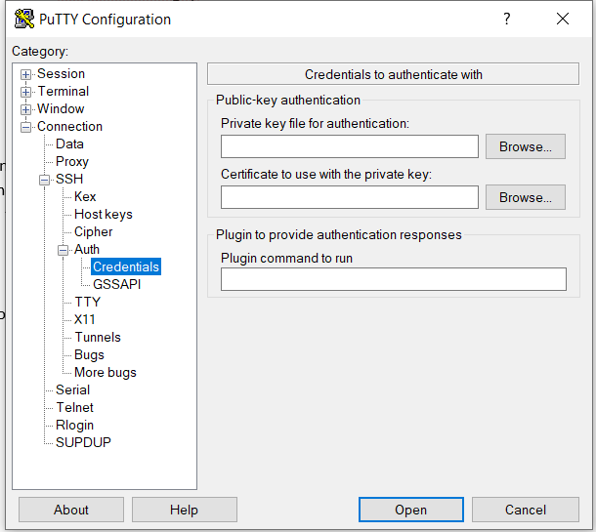
* Convert pem file to ppk file using the putty key generator
* Paste the ppk file in the (private key file for authentication ) then click open
* Connect the AWS instance on the putty.

**Connect the aws pem file to the Window power shell**

* ssh –i [pem file path] ec2-user@[ip of the instance ]